Adithya A K
https://www.linkedin.com/in/adithya-a-k-5a0381237/
Employee Life Cycle Management using Microsoft Entra id Joiner-Mover-Leaver

1, New Employee – Joiner
Joiner Process:
The Joiner stage represents the onboarding of a new employee into the organization. In this lab, Priya was created as a new user in Microsoft Entra ID and assigned the required employee information, including department, job title, employee ID, employee type, hire date, and office location. The account was created as an enabled user so that the employee could subsequently be assigned the appropriate organizational access.
This stage establishes the employee's digital identity in the organization's identity directory and provides the foundation for assigning groups, applications, roles, and other access required for the employee's job.
Test Employee Details
Name : Priya
Department : HR
Job title : HR Associate
User type : Member
Company : Adithya Tech Demo
Employee ID : 1003
Employee type : Permanent
Hire date : 21 September 2026
Office location : Kolkata

Group Assignment: Priya was added to the HR Department group, establishing her initial department-based access.
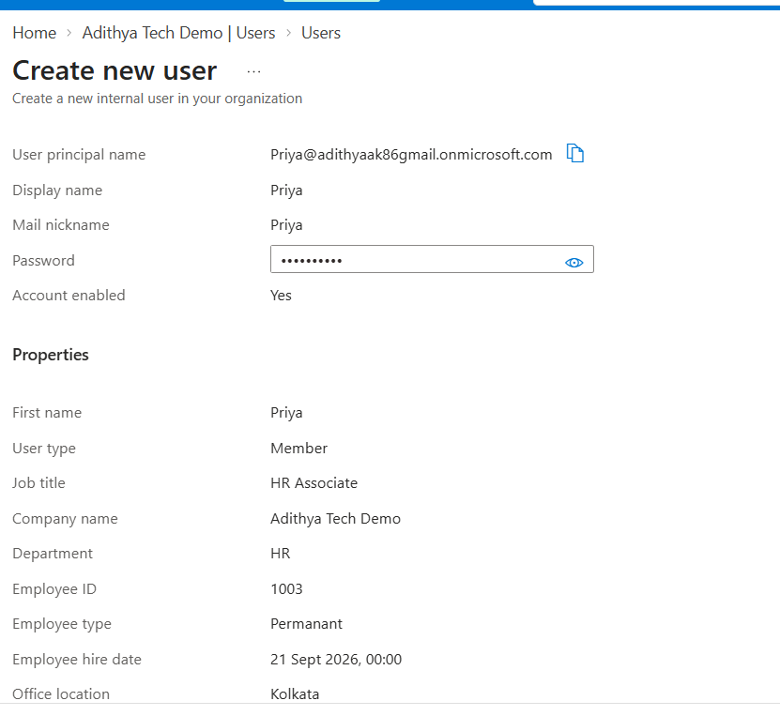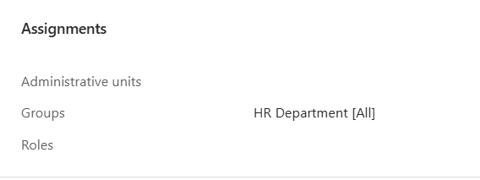

2, Employee Department Transfer - Mover
Mover Process:
The Mover stage handles changes to an employee's role, department, or responsibilities within the organization. In this scenario, Priya was transferred from the HR department to the IT department.
Her job title was updated from HR Associate to IT Support Associate, and her department was changed from HR to IT. Her previous HR Department group membership was removed as part of the transfer.
This demonstrates an important IAM principle: when an employee changes roles, their access should be reviewed and updated according to their new responsibilities. Access associated with the previous role should be removed where it is no longer required.
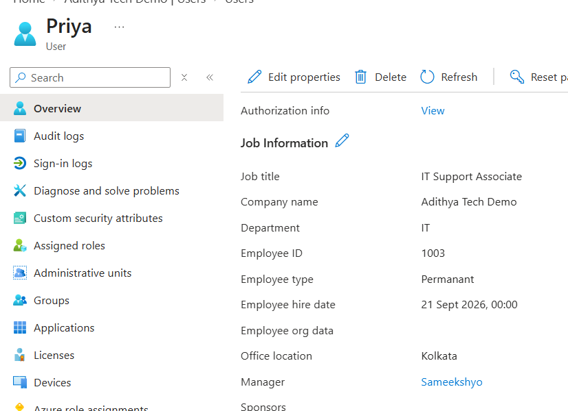

Priya
│
▼
HR Associate
│
│ Department Transfer
▼
IT Support Associate
│── Remove HR Group
│
└── Add IT Group

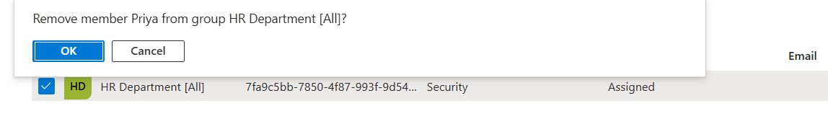
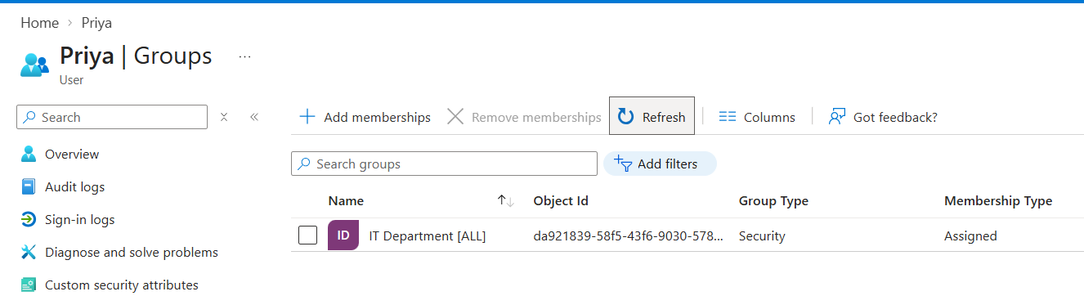

3. Employee Offboarding - Leaver
Leaver Process:
The Leaver stage is used when an employee leaves the organization due to resignation, retirement, or another form of separation.
In this scenario, Priya left Adithya Tech Demo. As part of the offboarding process, her Microsoft Entra account was disabled and her group membership was removed. Disabling the account prevents the user from signing in, while removing group membership helps remove access inherited through those groups.
In a production environment, the offboarding process can also include revoking active sessions and tokens, reviewing application assignments, removing device ownership where applicable, and retaining the account according to the organization's retention policy. Microsoft documents disabling users and invalidating active sessions/tokens as standard offboarding actions
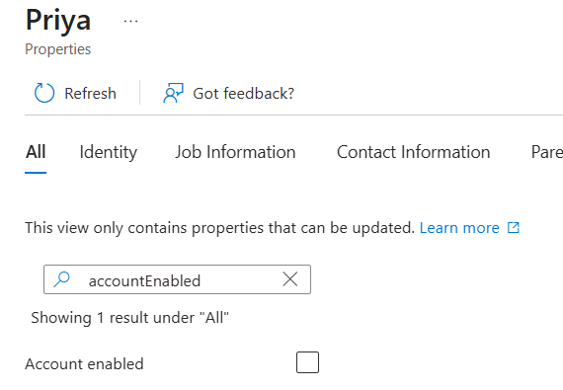
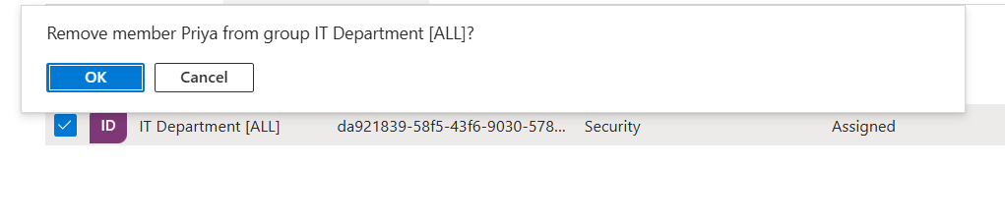

Deletion and Retention:
Disabling an account does not automatically place the user into the Microsoft Entra deleted-user state. When an administrator deletes the user, Microsoft Entra places the deleted account in a soft-deleted state for 30 days. During this period, the user can be restored. After the 30-day recovery period, permanent deletion occurs automatically

